**Operating Systems Lab ManualCSL303**

**Dr. Monika Yadav**

Department of Computer Science and Engineering TheNorthcap University

Gurugram- 122001, India

Session 2022-23

|  |  |  |  |  |  |
| --- | --- | --- | --- | --- | --- |
| **INDEX** | | | | | |
| **S. No.** | **Experiment** | **Date of Experiment** | **Date of Submission** | **CO Covered** | **Signature** |
| 1 | To familiarize the students to Linux interface and install Linux. | **3/8/2022** | **3/8/2022** |  |  |
| 2 | To write the shell programming code for the following.  a) Write A Shell Program of Hello World  b) Write a shell program to find factorial of a number.  c) Write a shell program to find gross salary of an employee.  d) Write a shell program to display the menu and execute instructions accordingly  (i)List of files (ii)Process Status (iii) Date (iv) users in program (v) Quit | **10/8/2022** | **10/8/2022** |  |  |
| 3 | To write the shell programming code for the following.  a) Write a shell program to find Fibonacci series.  b) Write a shell program to find largest of three numbers.  c) Write a shell program to find average of N numbers | **17/8/2022** | **17/8/2022** |  |  |
| 4 | To write the shell programming code for the following.  a) Write a shell program to check whether a number is even or odd  b) Write a shell program to find whether a number is prime or not.  c) Write a shell program to find whether a number is palindrome or not.  d) Write a shell program to type number 1 to 7 and then print its corresponding day of week | **28/8/2022** | **28/8/2022** |  |  |
| 5 | Implement the following CPU scheduling Algorithms.   1. FCFS with Arrival time   ii)FCFS without Arrival time | **7/9/2022** | **7/9/2022** |  |  |
| 6 | Implement the following CPU scheduling Algorithms.   * SJF (Non-Preemptive) * SJTF (shortest remaining time first -Preemptive SJF) | **14/9/2022** | **14/9/2022** |  |  |
| 7 | Implement the priority scheduling. |  |  |  |  |
| 8 | Implement the Round Robin scheduling. |  |  |  |  |
| 9 | Write a program to implement reader/writer problem using semaphore |  |  |  |  |
| 10 | Write a program to implement Dining Philosopher’s problem using semaphore |  |  |  |  |
| 11 | Write a program to implement Banker’s algorithm for deadlock avoidance. |  |  |  |  |
| 12 | Write a program for page replacement policy using a) LRU b) FIFO c) Optimal. |  |  |  |  |

**Experiment No: 1**

|  |
| --- |
| **Student Name and Roll Number: Avtar Singh / 20csu241** |
| **Semester /Section: 5th / FSB** |
| **Date: 3/8/2022** |
| **Faculty Signature:** |
| **Marks:** |

|  |
| --- |
| **Objective(s):**  To familiarize the students to Linux interface. |
| **Outcome:**   * The students will understand commands used in Linux. |
| **Problem Statement:**  Implement the following things:   * Cygwin Installation * Basic Linux commands |
| **Background Study:**  Cygwin is a open source tool which provides that functionality of the Linux in windows Operating System. Cygwin is a large collection of GNU and Open Source tools which provide functionality similar to a [Linux distribution](https://en.wikipedia.org/wiki/Linux_distribution) on Windows. It is a DLL (cygwin1.dll) which provides substantial POSIX API functionality. |
| **Question Bank:**   1. **What is Linux?**   Ans : Linux® is an open source operating system (OS). An operating system is the software that directly manages a system's hardware and resources, like CPU, memory, and storage. The OS sits between applications and hardware and makes the connections between all of your software and the physical resources that do the work.   1. **How will you List files from a directory?**   Ans : The ls command is used to list files. "ls" on its own lists all files in the current directory except for hidden files.   1. **How files in a directory can be removed?**   Ans : 1. To remove an empty directory, use either rmdir or rm -d followed by the directory name: rm -d dirname rmdir dirname.  2. To remove non-empty directories and all the files within them, use the rm command with the -r (recursive) option: rm -r dirname.   1. **How to find out a word in a file?**   Ans : Grep is a Linux / Unix command-line tool used to search for a string of characters in a specified file.   1. **What are wildcards?**   Ans : A wildcard is a symbol that takes the place of an unknown character or set of characters. |

**Student Work Area**

**Algorithm/Flowchart/Code/Sample Outputs**

**EXPERIMENT NO. 2**

|  |
| --- |
| **Student Name and Roll Number: Avtar Singh - 20csu241** |
| **Semester /Section:5th / FSB** |
| **Date:10/08/2022** |
| **Faculty Signature:** |
| **Marks:** |

|  |
| --- |
| **Objective:**  To write the shell programming code for the following. |
| **Outcome:**  Student is able to write code in shell programming |
| **Problem Statement:**  a) Write A Shell Program of Hello World  b) Write a shell program to find factorial of a number.  c) Write a shell program to find gross salary of an employee.  d) Write a shell program to display the menu and execute instructions accordingly  **(i)**List of files **(ii)**Process Status **(iii)** Date **(iv)** users in program **(v)** Quit |
| **Background Study:**  A shell script is a file with a set of commands in it. The shell reads this file and executes the instructions as if they were input directly on the command line.  A shell is a command-line interpreter and operations such as file manipulation, program execution and text printing is performed by shell script. So, we will use vi editor to edit our files. |
| **Question Bank:**   1. **What is a shell?**   Ans. The shell is **the layer of programming that understands and executes the commands a user enters**.   1. **What is the significance of $#?**   Ans.$# **shows the count of the arguments passed to the script**   1. **What are the different types of commonly used shells on a typical Linux system?**  * Ans.The Bourne Shell (sh) * The GNU Bourne-Again Shell (bash) * The C Shell (csh) * The Korn Shell (ksh) * The Z Shell (zsh)  1. **How will you pass and access arguments to a script in Linux?**   Ans.Arguments can be passed to the script when it is executed, **by writing them as a space-delimited list following the script file name**. Inside the script, the $1 variable references the first argument in the command line, $2 the second argument and so forth. The variable $0 references to the current script.   1. **Use sed command to replace the content of the file (emulate tac command) ?**   **sed -i 's/old-text/new-text/g' input.txt** |

**Student Work Area**

**Algorithm/Flowchart/Code/Sample Outputs**

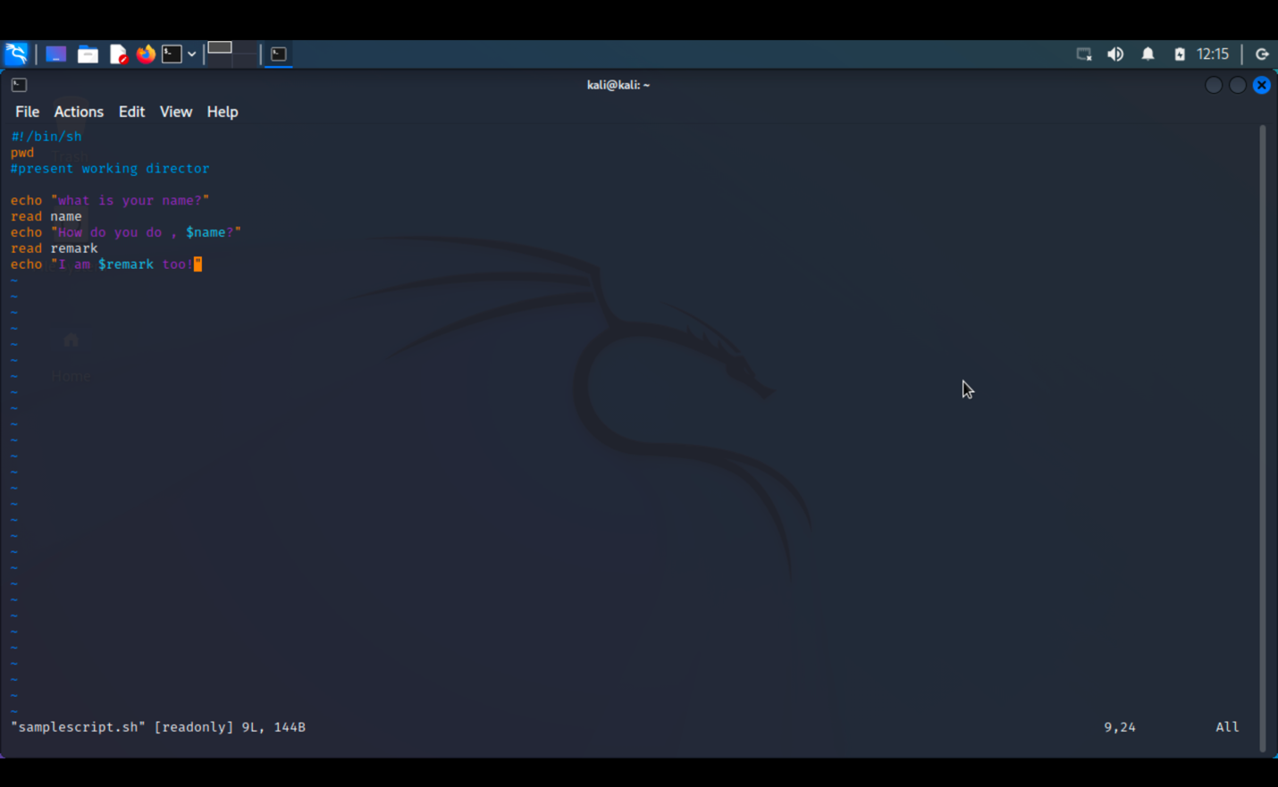

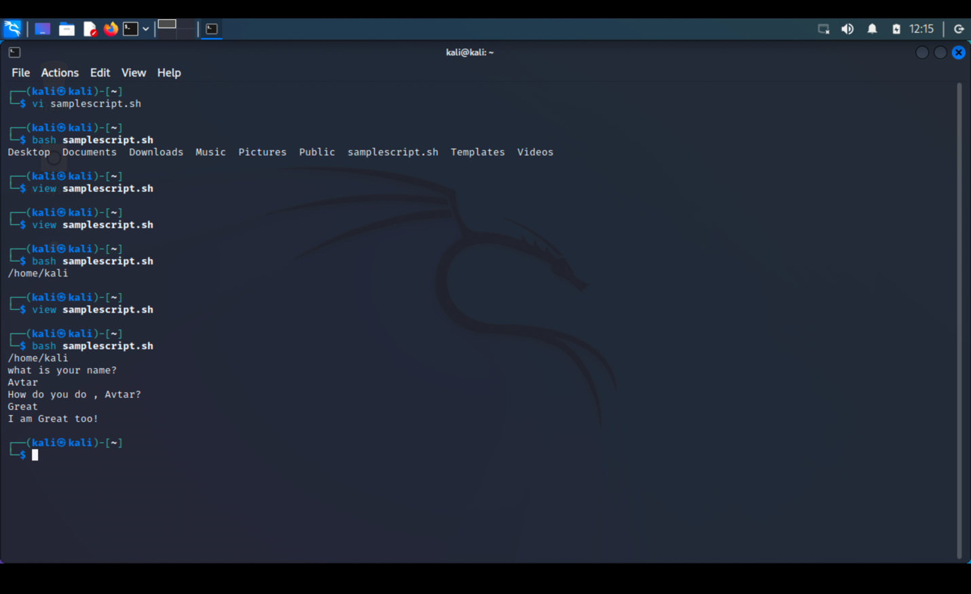

**a) Write A Shell Program of Hello World**

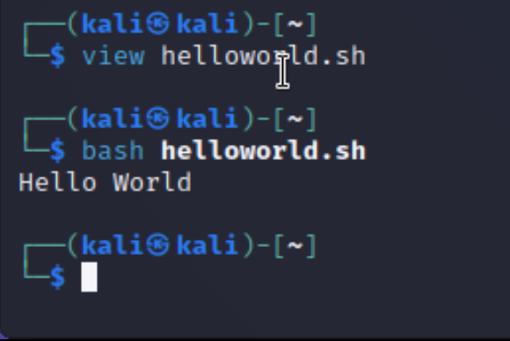

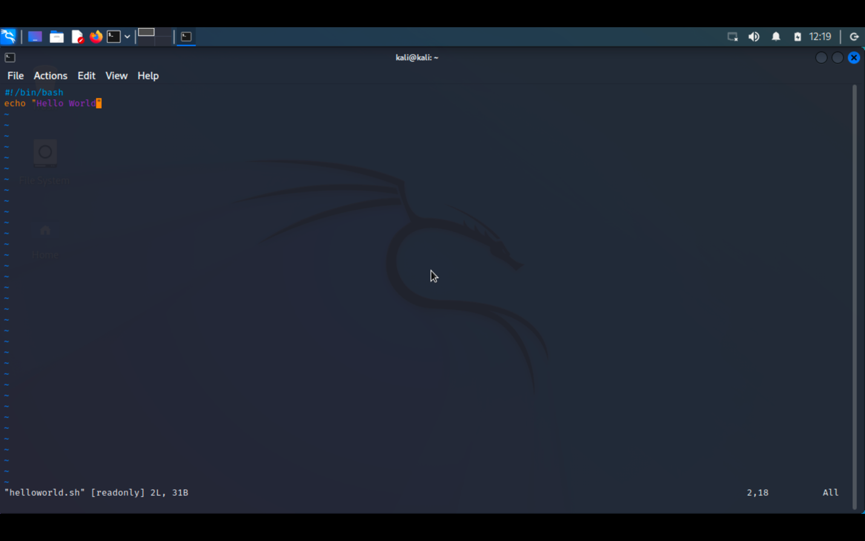

**b) Write a shell program to find factorial of a number.**

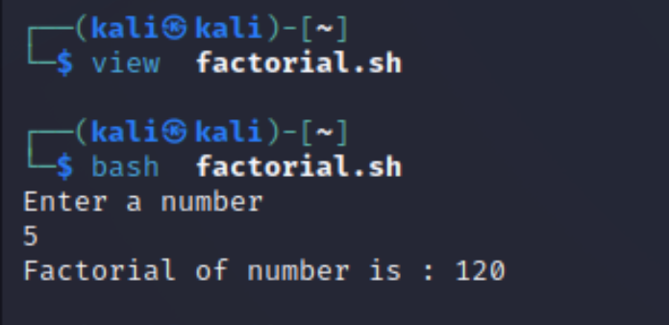

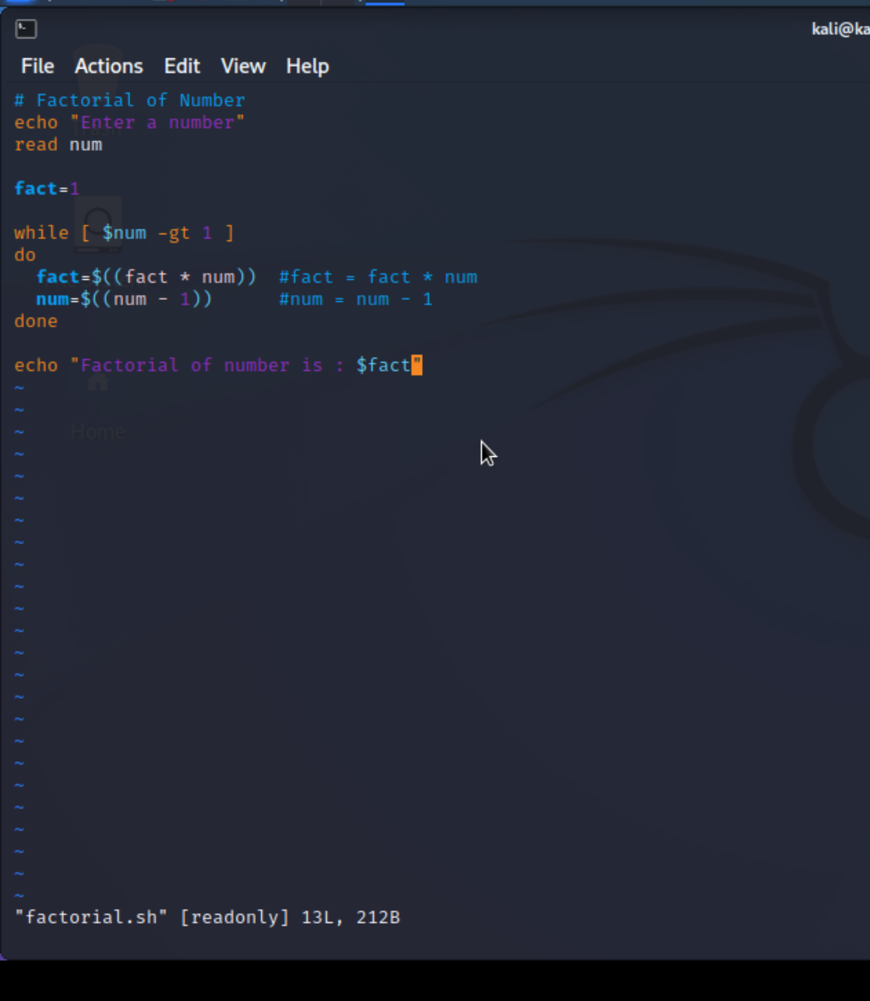

**c) Write a shell program to find gross salary of an employee.**

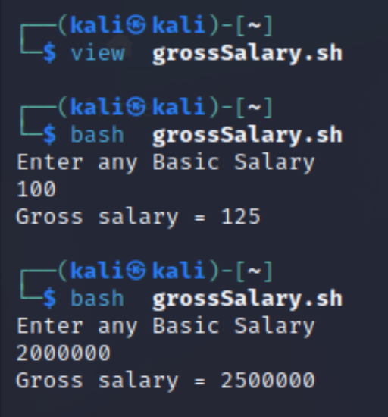

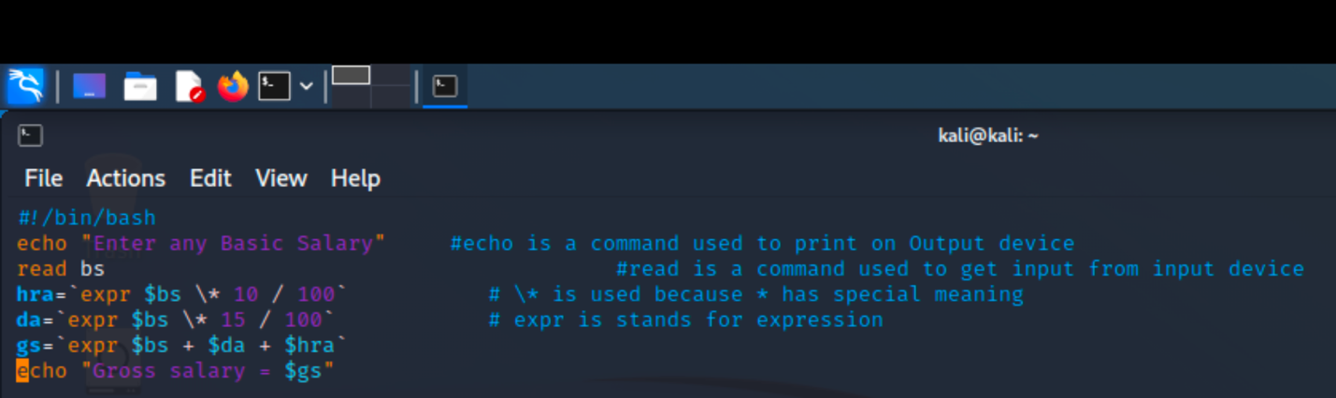

**d) Write a shell program to display the menu and execute instructions accordingly**

**(i)List of files (ii)Process Status (iii) Date (iv) users in program (v) Quit**

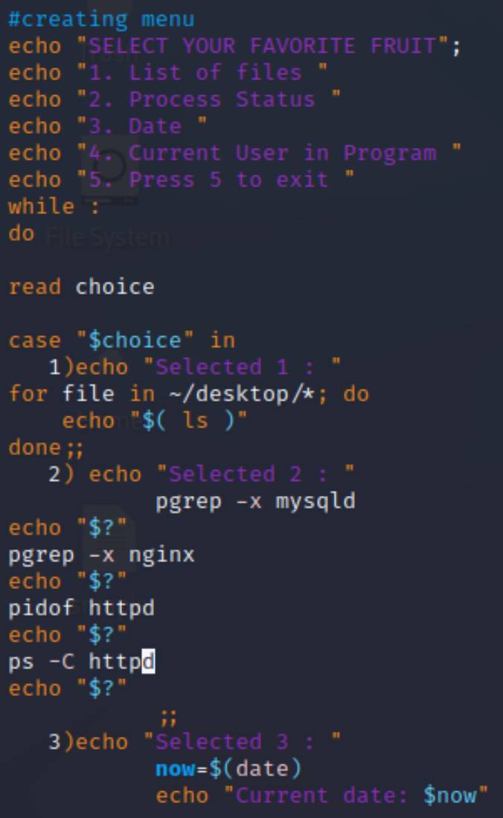

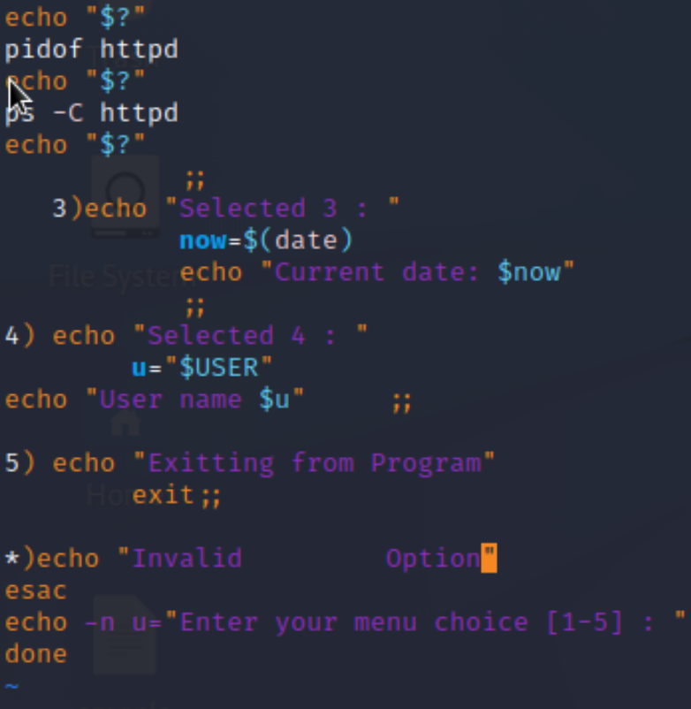

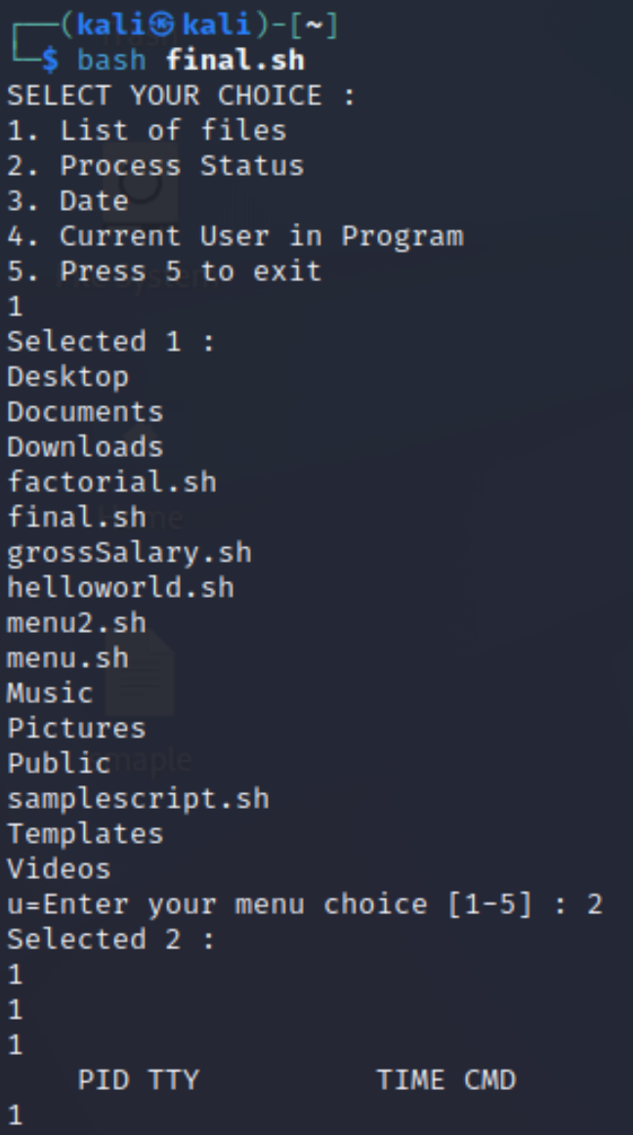

**EXPERIMENT NO. 3**

|  |
| --- |
| **Student Name and Roll Number: Avtar Singh - 20CSU241** |
| **Semester /Section: 5th / FSB** |
| **Date: 24/08/2022** |
| **Faculty Signature:** |
| **Marks:** |

|  |
| --- |
| **Objective:**  To write the shell programming code for the following. |
| **Outcome:**  Student is able to write code in shell programming |
| **Problem Statement:**  a) Write a shell program to find Fibonacci series.  b) Write a shell program to find largest of three numbers.  c) Write a shell program to find average of N numbers |
| **Background Study:**  A shell script is a file with a set of commands in it. The shell reads this file and executes the instructions as if they were input directly on the command line.  A shell is a command-line interpreter and operations such as file manipulation, program execution and text printing is performed by shell script. So, we will use vi editor to edit our files. |
| **Question Bank:**   1. **How to use multi line comments in shell script?**   Ans : In Shell or Bash shell, we can comment on multiple lines **using << and name of comment**. we start a comment block with << and name anything to the block and wherever we want to stop the comment, we will simply type the name of the comment.   1. **What is the difference between soft and hard links?**   Ans : A hard link is a file all its own, and the file references or points to the exact spot on a hard drive where the Inode stores the data. A soft link isn't a separate file, it points to the name of the original file, rather than to a spot on the hard drive.   1. **Explain about loops and what are the loops available in LINUX?**   Ans : The for loop **operates on lists of items**. It repeats a set of commands for every item in a list.  There are **three types of shell loops** in UNIX/Linux: for loop. while loop. until loop.  You will use different loops based on the situation. For example, **the while loop executes the given commands until the given condition remains true; the until loop executes until a given condition becomes true**.   1. **What are absolute and relative paths.**   Ans : **An absolute path is defined as specifying the location of a file or directory from the root directory(/)**. In other words,we can say that an absolute path is a complete path from start of actual file system from / directory. Relative path is defined as the path related to the present working directly(pwd).   1. **How to debug a shell script.**   Ans : The debugging options available in the Bash shell can be switched on and off in multiple ways. Within scripts, we can either use the set command or add an option to the shebang line. However, another approach is to explicitly specify the debugging options in the command-line while executing the script. |

**Student Work Area**

**Algorithm/Flowchart/Code/Sample Outputs**

**a) Write a shell program to find Fibonacci series.**

**Program :**

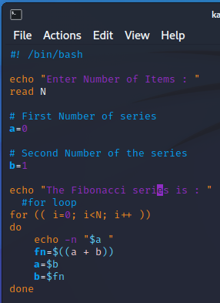

Output :

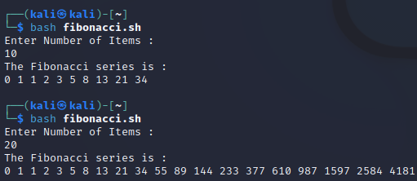

**b) Write a shell program to find largest of three numbers.**

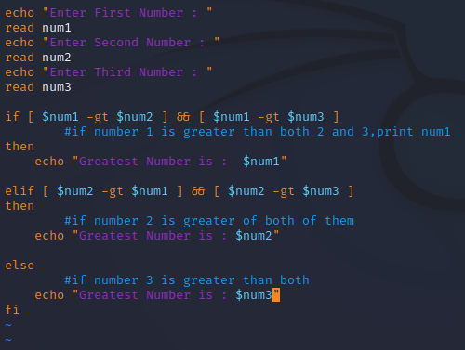

**OUTPUT :**

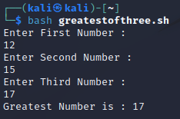

**c) Write a shell program to find average of N numbers**

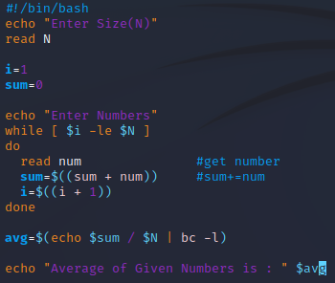

**Output :**

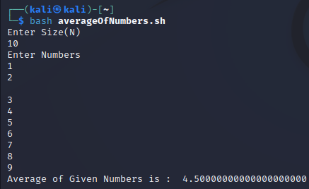

**EXPERIMENT NO. 4**

|  |
| --- |
| **Student Name and Roll Number: Avtar Singh - 20csu241** |
| **Semester /Section: 5th /FSB** |
| **Date: 31/08/2022** |
| **Faculty Signature:** |
| **Marks:** |

|  |
| --- |
| **Objective:**  To write the shell programming code for the following. |
| **Outcome:**  Student is able to write code in shell programming |
| **Problem Statement:**  a) Write a shell program to check whether a number is even or odd  b) Write a shell program to find whether a number is prime or not.  c) Write a shell program to find whether a number is palindrome or not.  d) Write a shell program to type number 1 to 7 and then print its corresponding day of week |
| **Background Study:**  A shell script is a file with a set of commands in it. The shell reads this file and executes the instructions as if they were input directly on the command line.  A shell is a command-line interpreter and operations such as file manipulation, program execution and text printing is performed by shell script. So, we will use vi editor to edit our files. |
| **Question Bank:**   1. **What are Zoombie Process?**   On Unix and Unix-like computer operating systems, a zombie process or defunct process is a process that has completed execution (via the exit system call) but still has an entry in the process table: it is a process in the "Terminated state".   1. **What are different types of variables used in shell script?**   Two types of variables can be used in shell programming: Scalar variables. Array variables.   1. **What are the different types of modes available in Vi editor?** 2. Command Mode 3. Insert Mode 4. Escape Mode 5. **What are the different types of permission at file level in shell?**   1)Owner Permission  2)Group Permission  3)Other (World) Permission   1. **How to use comments in shell script.** # |

**Student Work Area**

**Algorithm/Flowchart/Code/Sample output**

**a) Write a shell program to check whether a number is even or odd**

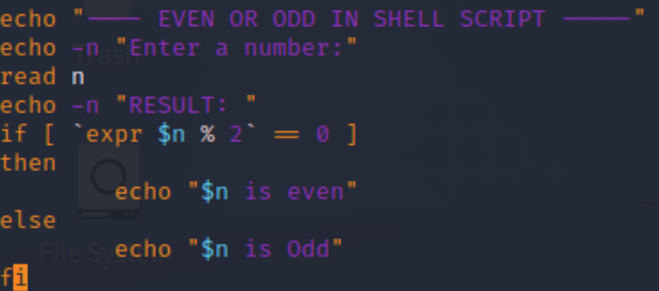

**b) Write a shell program to find whether a number is prime or not.**

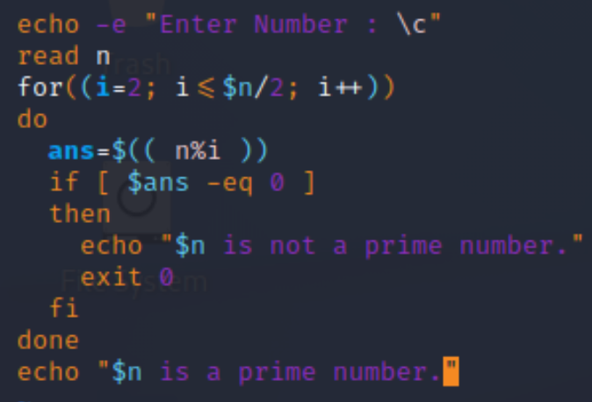

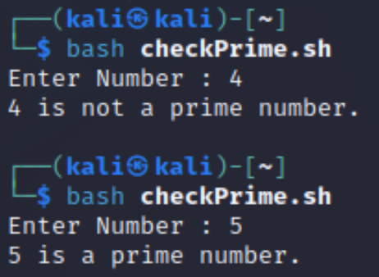

**c)Write a shell program to find whether a number is palindrome or not.**

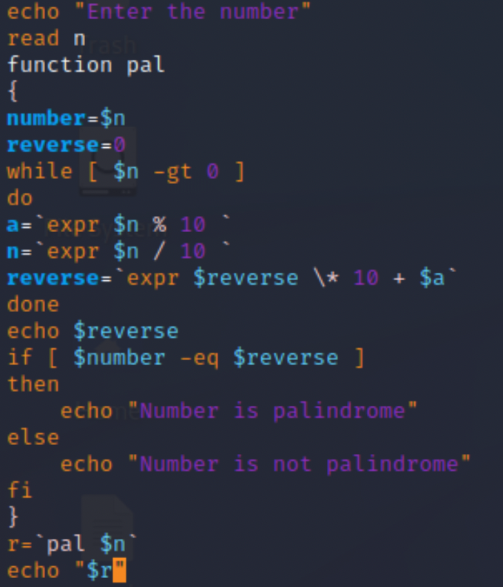

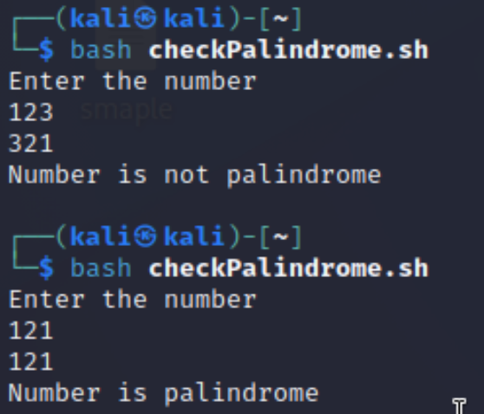

**d) Write a shell program to type number 1 to 7 and then print its corresponding day of week**

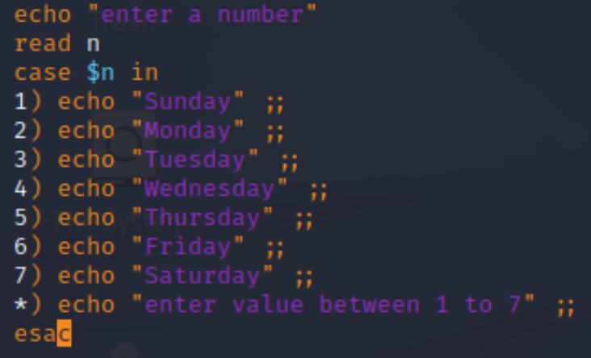

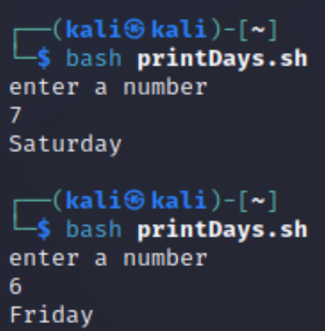

**Experiment No: 5**

|  |
| --- |
| **Student Name and Roll Number: Avtar Singh / 20csu241** |
| **Semester /Section: 5th / FSB** |
| **Date: 7/9/2022** |
| **Faculty Signature:** |
| **Marks:** |

|  |
| --- |
| **Objective:**  Write a program to implement CPU scheduling for first come first serve approach. |
| **Outcome:**  The students will understand the First-cum-first-serve algorithm |
| **Problem Statement:**  Implement the following CPU scheduling Algorithms.   1. FCFS with Arrival time 2. FCFS without Arrival time |
| **Background Study:**  **FCFS**   * The simplest CPU-scheduling algorithm is the first-come, first-served (FCFS) scheduling algorithm. With this algorithm, processes are assigned the CPU in the order they request it. * There is a single queue of ready processes. * The implementation of the FCFS policy is easily managed with a FIFO queue. When a process enters the ready queue, its PCB is linked onto the tail of the queue. * The average waiting time under the FCFS policy, however, is often quite long. |
| **Question Bank:**   1. Which module gives control of the CPU to the process selected by the short-term scheduler?    1. **dispatche**r    2. interrupt    3. scheduler    4. none of the mentioned 2. The processes that are residing in main memory and are ready and waiting to execute are kept on a list called    1. job queue    2. **ready queue**    3. execution queue    4. process queue 3. The interval from the time of submission of a process to the time of completion is termed as    1. waiting time    2. **turnaround time**    3. response time    4. throughput 4. Which scheduling algorithm allocates the CPU first to the process that requests the CPU first?    1. **first-come, first-served scheduling**    2. shortest job scheduling    3. priority scheduling    4. none of the mentioned 5. In priority scheduling algorithm    1. **CPU is allocated to the process with highest priority**    2. CPU is allocated to the process with lowest priority    3. equal priority processes cannot be scheduled    4. none of the mentioned |

**Student Work Area**

**Algorithm/Flowchart/Code/Sample Outputs**

**Q. Implement the following CPU scheduling Algorithms.**

1. **FCFS with Arrival time**

**Program :**

*#include <stdio.h>*

*int main() {*

*int bt[10] = {0}, at[10] = {0}, tat[10] = {0}, wt[10] = {0}, ct[10] = {0};*

*int n, sum = 0;*

*float totalTAT = 0, totalWT = 0;*

*printf("Enter number of processes ");*

*scanf("%d", &n);*

*printf("Enter arrival time and burst time for each process\n\n");*

*for (int i = 0; i < n; i++) {*

*printf("Arrival time of process[%d] ", i + 1);*

*scanf("%d", &at[i]);*

*printf("Burst time of process[%d] ", i + 1);*

*scanf("%d", &bt[i]);*

*printf("\n");*

*}*

*// calculate completion time of processes*

*for (int j = 0; j < n; j++) {*

*sum += bt[j];*

*ct[j] += sum;*

*}*

*// calculate turnaround time and waiting times*

*for (int k = 0; k < n; k++) {*

*tat[k] = ct[k] - at[k];*

*totalTAT += tat[k];*

*}*

*for (int k = 0; k < n; k++) {*

*wt[k] = tat[k] - bt[k];*

*totalWT += wt[k];*

*}*

*printf("Solution: \n\n");*

*printf("P#\t AT\t BT\t CT\t TAT\t WT\t\n\n");*

*for (int i = 0; i < n; i++) {*

*printf("P%d\t %d\t %d\t %d\t %d\t %d\n", i + 1, at[i], bt[i], ct[i], tat[i],*

*wt[i]);*

*}*

*printf("\n\nAverage Turnaround Time = %f\n", totalTAT / n);*

*printf("Average WT = %f\n\n", totalWT / n);*

*return 0;*

*}*

**b) FCFS without Arrival time**

**Program :**

*#include <stdio.h>*

*int main() {*

*int n, bt[20], wt[20], tat[20], avwt = 0, avtat = 0, i, j;*

*printf("Enter total number of processes(maximum 20):");*

*scanf("%d", &n);*

*printf("\nEnter Process Burst Time\n");*

*for (i = 0; i < n; i++) {*

*printf("P[%d]:", i + 1);*

*scanf("%d", &bt[i]);*

*}*

*wt[0] = 0; // waiting time for first process is 0*

*// calculating waiting time*

*for (i = 1; i < n; i++) {*

*wt[i] = 0;*

*for (j = 0; j < i; j++)*

*wt[i] += bt[j];*

*}*

*printf("\nProcess\t\tBurst Time\tWaiting Time\tTurnaround Time");*

*// calculating turnaround time*

*for (i = 0; i < n; i++) {*

*tat[i] = bt[i] + wt[i];*

*avwt += wt[i];*

*avtat += tat[i];*

*printf("\nP[%d]\t\t\t%d\t\t\t%d\t\t\t\t%d", i + 1, bt[i], wt[i], tat[i]);*

*}*

*avwt /= i;*

*avtat /= i;*

*printf("\n\nAverage Waiting Time:%d", avwt);*

*printf("\nAverage Turnaround Time:%d", avtat);*

*return 0;*

*}*